**Magic Mirror**

**Project Team Members**

Behram Dossabhoy

Jonah Landry

Jason Myles

**Project Summary**

The Magic Mirror will fetch data from Yahoo’s weather API to tell a user what the weather will be like that day and for the next three days. The mirror will also be able to tell the user of the next three upcoming events in their schedule as well as the current time.

**Goals and Objectives**

A mirror that displays necessary information such as date, time, weather, and the user’s daily schedule every morning. It should be able to be fed a calendar and fetch weather data for a user’s specified location.

**Bill of Materials**

In the end, only a Raspberry Pi was used complete with the kit provided to us by Louisana Tech. The program/project was built using Python 2.7, Yahoo’s weather API, and Google’s Calendar API.

**GPIO**

For now, the system will be self-contained in the RPi, but in the future, we will utilize a bigger, reflective screen for the user. While you can use a one-way mirror, old monitors are reflective enough to serve the purpose of a mirror.

**GUI**

The GUI will have no interaction with the user as the mirror is to be able to operate without user interference. The GUI will be minimal, as it is supposed to act as a mirror. This could be accomplished by GUI elements being located at the mirror’s corners.

**GitHub Repository**

This project's GitHub repository is located at: <https://github.com/bnd011/MagicMirror>

**Gantt Chart**

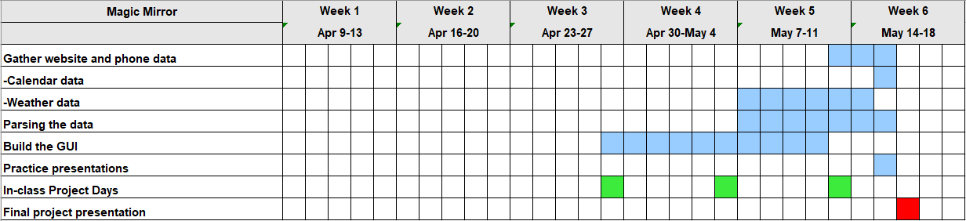

**Future Development Plans**

If we were to continue working on the project, we would implement a more interactive interface and a larger screen. Specifically, a large LCD touchscreen as well as a way for the user to tap on the upcoming events and bump off or add new events to their schedule.

**Lessons Learned**

We learned that stack overflow is god. We also learned that it’s less important that you know exactly what code does and more that you know good programming practice. Because it doesn’t matter if you know exactly what .after or .urlencode does but more so that you know what your code needs to do. This related to living with cyber because the lessons focused less on python and more on the general concepts. As for problem solving in general, we learned that we need to keep up with the entire groups’ schedule and try to plan things much further in advance. Regarding future courses in the curriculum, the project helped us learn how to work through new situations in coding via internet resources.